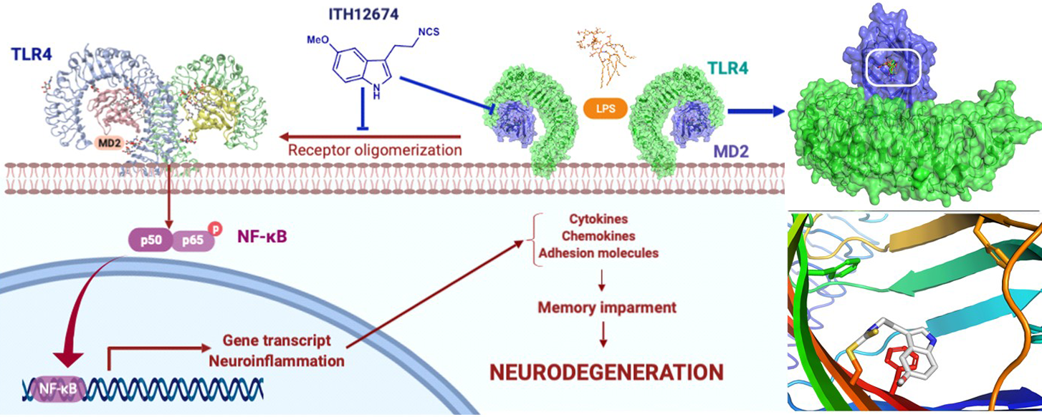
Postdoctoral Position in Organic Chemistry
The Nerodrugs Group at the Medicinal Chemistry Institute, CSIC, is seeking an outstanding organic chemist to be part of a multidisciplinary team including organic chemists, pharmacologists, molecular biologists, neuroscientists and medical doctors focusing in the development of novel therapeutics for neurodegenerative diseases (Alzheimer’s disease, Parkinson’s disease, ictus and Multiple Sclerosis).
Lab website: https://www.iqm.csic.es/en/neurodrugs/
Publications: https://orcid.org/my-orcid?orcid=0000-0003-4017-5756
Project
Next-Generation Therapies for Alzheimer’s Disease: Innovation in Drug Design and Development. (NexT-ALZ)
Qualifications and experience for candidates:
- Highly motivated for advanced organic chemistry with valuable experience in any of the following fields:
  - heterocyclic chemistry,
  - enantioselective organocatalytic catalysis,
  - total synthesis,
  - biologically active compounds.
- organization and communication skills
- Supervisory and team members guidance interest (Selected candidate will be invited as co-supervisor of PhD and TFM students)
- Interest in the development of his/her own research projects.
We offer:
- Integration in a highly active and multidisciplinary research team devoted to the development of novel therapeutics for neurodegenerative diseases.
- An opportunity with future projection to accomplish the scientific career in the most recognized research institution in Spain.
- Highly collaborative group with ongoing collaborations at national and international level.
- Advanced training in organic chemistry, pharmacology, molecular biology, management and trainee supervision.
Contract is available from 01/01/2026 following CSIC contracts guidance and we offer the possibility to apply to the JUAN DE LA CIERVA fellowship to ensure three more years contract.
Contact: interested candidates should send a motivation letter, CV and two references. via e-mail DEADLINE FOR APPLICATIONS: 01/12/2025
Rafael León, Ph.D
Tenured Scientist (IQM-CSIC)
e-mail: rafael.leon@iqm.csic.es
Phone: (0034) 91 258 74 21

