Call for a predoctoral fellowship candidate
Ocean warming and acidification pose significant threats to benthic species, endangering essential ecosystem services such as fisheries and shoreline protection. As atmospheric CO₂ levels continue to rise, their impacts on seawater temperature and pH are projected to intensify by mid-century without decisive climate mitigation. Understanding the acclimatization potential of marine species to these stressors becomes crucial for anticipating shifts in community structure, ecosystem stability, and the continued provision of essential services.
We are seeking an enthusiastic and highly motivated candidate in Molecular Biology or related fields to join our team and apply for competitive national and international predoctoral (FPU, etc.) fellowships.
Successful candidates, upon award of a fellowship, will participate in the MedAcidWarm national research project that aims to boost our understanding on acclimatory responses of benthic invertebrates and their associated microbiomes to projected ocean warming and acidification and reconstruct past seawater temperature and pH changes using invertebrate skeletons, applying cutting-edge approaches such as MicroCT, metabolomics, microbiome, and transcriptomic analyses.
Selected candidates will be integrated into the Medrecover reseach group recognized as a consolidated research group by the Generalitat de Catalunya (https://medrecover.org/), with a strong track record in marine conservation and mentoring PhD students and postdoctoral researchers. They will also collaborate with national and international researchers in a dynamic and multidisciplinary research environment.
The successful candidate will be involved in several tasks that include:
- Conduct field and/or laboratory experimental studies.
- Prepare and publish high-quality research papers in peer-reviewed journals and present findings at national and international conferences.

- Collaborate with an international network of researchers.
- Contribute to grant writing efforts to secure funding for ongoing and future research projects.
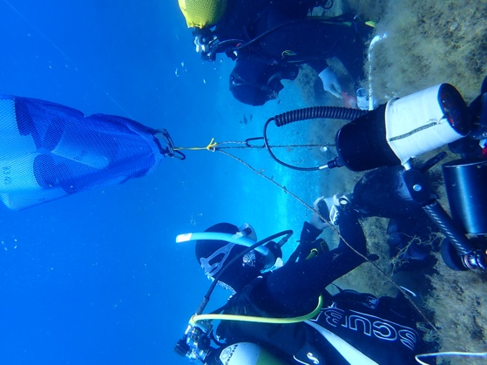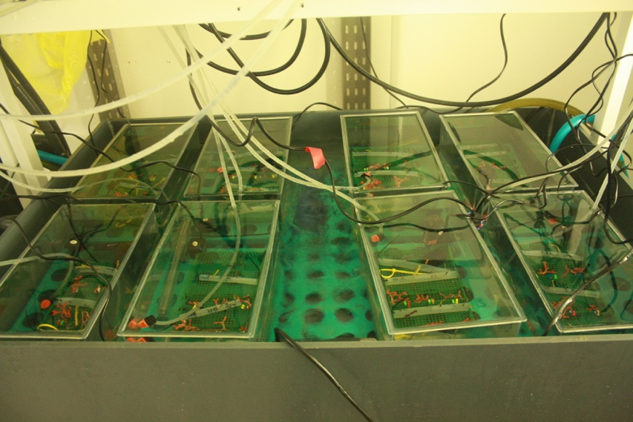

Expected background and skills for the predoctoral fellowship
- Degree in Molecular Biology, Microbiology, Chemistry or related fields.
- Strong academic record.
- Publications in peer-reviewed journals (desirable).
- Good oral and written communication skills in English and Spanish (desirable).
- Prior experience in marine science research (desirable).
- Proactive, flexible, problem-solving, and team-oriented mindset.

Host Institution
The Institut de Ciències del Mar (ICM) is the largest marine research centre of the Spanish National Research Council (CSIC). It is also the first marine science centre to be accredited as a Severo Ochoa Centre of Excellence, a recognition to the institution’s leadership in the field of marine research in Spain and to its commitment to create social impact.
Our goal is to develop research of excellence to inspire a society in harmony with the blue planet, in line with the values of the United Nations Decade of Ocean Science for Sustainable Development (2021-2030).
For further information, please visit our website.

The CSIC and all its research centers were awarded with the "HR Excellence in Research" seal in 2021. This recognition reflects our commitment to continuously improve our human resources policies in line with the European Charter for Researchers and the Code of Conduct for the Recruitment of Researchers.

Application procedure
Interested candidates should send:
- A motivation letter
- Their CV
- Academic transcript for the Bachelor’s degree (overall average mark above 8/10)
- Academic transcript for my Master’s degree (overall average mark above 8/10)
by December 15th to: figuerola@icm.csic.es
Applications will be reviewed on a rolling basis. Shortlisted candidates will be invited for an interview.

