Project study sites included in the database according to the current Köppen climate classification. In Argentina, the asterisks indicate sites that are not yet dated.

Time period: Last 150.000 years with especial emphasis on MIS 5 (last global warming) and MIS2-1 Last Glacial Maximum (transition from the Late Pleistocene to the Holocene. Divisions based on isotopic data (Railsback, L et al. 2015; based, in turn, on data from Emiliani,1955, 1961, and Martinson et al. 1987).
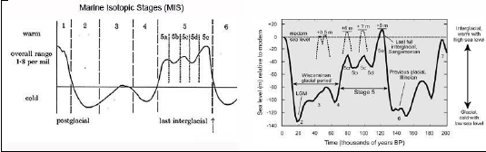
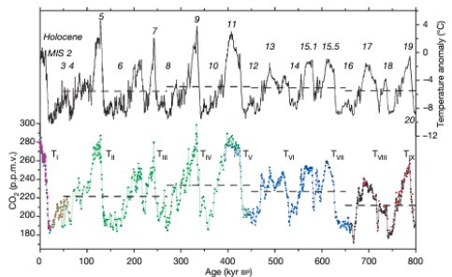  a | b
CO2 and temperature records from EPICA (Ice Coring in Antarctica, Lüthi et al. 2008 https://doi.org/10.1038/nature06949 and methane content in Greenland and Antarctica showing certain delay in the southern ice core compared to the north one Blunier et al. 2007 https://doi.org/10.5194/cp-3-325-2007

